Q1 | Drone Medicine Delivery in a Flood Zone

Scenario: AI-powered drones deliver emergency medicines in a flood-affected region. Roads become inaccessible suddenly, weather changes travel cost, and the drone has only a straight-line distance heuristic plus partial real-time updates. Routes must be chosen quickly with minimum delay and risk.

Problem Formulation
- States: drone position (waypoint or grid cell) on the regional map graph, plus battery level.
- Actions: move to a neighbouring waypoint.
- Step cost g: depends on distance, terrain and weather (wind or storm raises the cost of an edge).
- Heuristic h(n): straight-line (Euclidean) distance to the hospital or relief camp.
- Goal test: the drone is at the delivery location with the medicine intact.

(a) Greedy Best-First Search (GBFS) in this scenario
GBFS expands the node that looks closest to the goal, using the evaluation function f(n) = h(n). It completely ignores the cost already spent, g(n).
Behaviour: the drone always heads toward the waypoint with the smallest straight-line distance to the destination. In open terrain this produces a very fast, nearly direct flight with very few node expansions. When a flooded river or blocked road lies on the straight line, the drone keeps being pulled toward it, reaches the obstacle, and only then backtracks.
Strengths | Weaknesses under uncertainty
Very fast decision-making; few nodes expanded | Not optimal: ignores terrain and weather cost, so it may choose a long, stormy route
Low memory use, suitable for on-board processors | Not complete in graph search with loops unless a closed list is used
Reacts quickly when a new percept arrives, since it only compares h-values | Gets trapped in dead ends: straight-line distance does not know that a river or collapsed bridge blocks the way
Good for a quick first estimate when time is extremely tight | Risk-blind: it cannot avoid dangerous but short regions

(b) A* Search in the same situation
A* uses f(n) = g(n) + h(n), where g(n) is the actual cost from the start (distance, terrain penalties, weather) and h(n) is the estimated remaining cost. It always expands the node with the lowest estimated total path cost.
- Balance: g(n) keeps the search honest about the real cost already paid (storm, rough terrain), while h(n) pulls the search toward the goal and prevents blind exploration.
- Optimality condition: if h(n) is admissible (never overestimates the true cost) and consistent, A* returns the least-cost path. Straight-line distance is admissible provided every edge cost is at least its geometric length. Weather and terrain only multiply cost by a factor of 1 or more, so the condition holds.
- Behaviour: when a stormy direct route becomes expensive, f(n) rises for those nodes and A* automatically shifts to a longer but calmer route.
Worked example. Start S, goal G. Path A: S→A cost 2, A→G cost 12 (storm). Path B: S→B cost 4, B→G cost 5. Heuristics: h(A)=4, h(B)=6.
Step | Greedy Best-First | A*
Compare A and B from S | h(A)=4 < h(B)=6, so choose A | f(A)=2+4=6, f(B)=4+6=10, so expand A first
Continue | From A go to G | G via A has f=14, which is more than f(B)=10, so expand B
Result | Path S-A-G, total cost 14 | G via B has f=9, popped first: path S-B-G, total cost 9 (optimal)

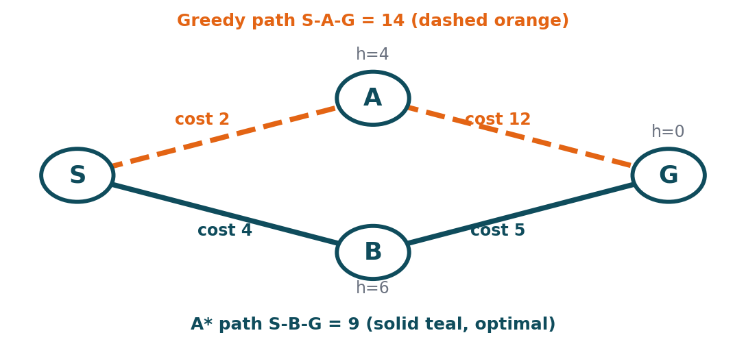
Figure 1: Worked example: Greedy follows the lowest h and pays 14, A* weighs g + h and finds 9

(c) Impact of heuristic accuracy
Heuristic quality | Effect on Greedy | Effect on A*
Accurate (close to the true cost) | Goes almost straight to the goal, very fast | Expands very few nodes and stays optimal
Under-estimates (admissible but loose, e.g. h=0) | Loses guidance and behaves almost randomly | Still optimal, but slower; with h=0 it becomes Dijkstra / Uniform-Cost Search
Over-estimates (inadmissible) | Pushes the drone aggressively in one direction, higher chance of dead ends | Faster, but may miss the optimal route (suboptimal path)
Ignores terrain and weather (pure straight-line) | Strongly misleading in floods; it chases roads that are blocked or dangerous | Safe because g(n) captures real cost, but expands more nodes
Key point: the quality of the heuristic decides GBFS correctness, since it has no other safeguard. For A*, heuristic quality decides only efficiency, as long as it stays admissible. A better heuristic for this scenario is terrain-aware, for example h = straight-line distance × minimum terrain factor, which remains admissible and is more informative.
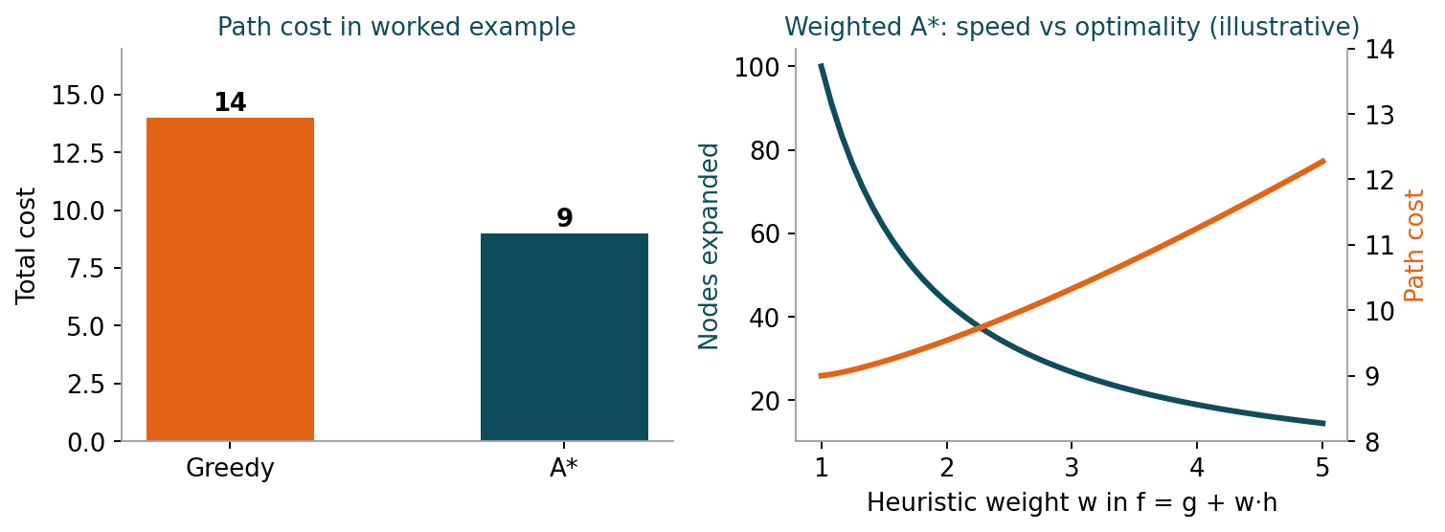
Figure 2: Path cost comparison and the speed versus optimality trade-off in Weighted A*

(d) Impact of dynamic changes (blocked paths)
- Plan invalidation: a blocked road makes the current path useless and the stored g and h values outdated.
- GBFS: reacts cheaply by re-selecting the next best-looking node, but it can repeatedly walk into newly blocked or dead-end areas and has no cost memory to recover efficiently.
- Plain A*: must re-plan from scratch after every update. This is optimal for the current map but expensive when updates arrive frequently.
- Partial information: the drone sees blockages only locally, so a plan computed on stale data may be wrong. The agent needs a continuous sense-plan-act loop.
- Remedies: incremental re-planning such as D* Lite / Lifelong Planning A* reuse earlier search effort and repair only affected nodes. Anytime A* / Weighted A* gives a quick feasible route first and improves it while time remains. A receding-horizon approach replans only a few waypoints ahead.

(e) Recommendation
Recommended: A* (in its dynamic form, D* Lite or Weighted A*) with a terrain- and weather-aware, admissible heuristic.
Criterion | Greedy Best-First | A* / D* Lite
Speed (real-time) | Fastest | Slightly slower, but incremental updates keep it real-time
Optimality | No guarantee | Optimal with admissible h
Safety / risk | Risk-blind | Risk and weather can be added directly into g(n)
Handles blocked paths | Poorly (dead ends) | Well, with D* Lite repairing only affected parts
Memory | Low | Higher, but acceptable on modern drone hardware

Conclusion: Because medicines are time critical and a failed route costs lives, safety and near-optimality matter more than the small speed advantage of Greedy search. Use A* with weighted heuristic (Weighted A*) under a strict time budget and D* Lite for re-planning when blocked-path updates arrive. Greedy search can serve only as an emergency fallback when the computation deadline is about to expire.

Q2 | Smart-City Traffic Signal Optimisation

Scenario: An AI system optimises signal timings across hundreds of intersections to minimise total waiting time, fuel consumption and congestion. The search space is huge, traffic changes dynamically, and the system may get stuck in locally optimal solutions.

(a) Formulation as an optimisation problem
- Decision variables: for each intersection i: cycle length C_i, green split for each phase, and offset O_i (relative start time to neighbouring signals).
- State: the complete set of signal timings for all N intersections, x = (x_1, x_2, ..., x_N).
- Objective (to minimise): f(x) = w1·(Total waiting time) + w2·(Fuel consumption) + w3·(Congestion index), with weights w1, w2, w3 set by city policy.
- Constraints: minimum and maximum green time, pedestrian crossing time, emergency-vehicle priority, fixed cycle bounds.
- Neighbour (move): change one timing parameter of one intersection by a small step.
- Evaluation: f(x) is computed from a traffic simulation or live sensor data.
Why traditional search is inefficient:
- Exponential search space: with 300 intersections and only 20 settings each, there are 20^300 combinations. BFS, DFS and A* cannot enumerate this.
- No explicit goal state: the aim is the best configuration, not reaching a known goal; the path to it is irrelevant.
- Costly evaluation: every state must be simulated, and the number of expansions needed is unaffordable.
- Dynamic environment: by the time a systematic search finishes, the traffic pattern has already changed.
- No good admissible heuristic: the cost interactions between neighbouring intersections are complex.
Hence local search and metaheuristics that hold only one state (or a small population) and improve it iteratively are more suitable.

(b) Hill Climbing in this scenario and its limitations
Hill Climbing starts from the current signal plan, examines neighbouring plans (for example, lengthening the green phase at one junction by 5 seconds), and moves to the neighbour that gives the best improvement in f(x). It stops when no neighbour is better.
current = initial signal plan
loop:
neighbour = best successor of current (lowest f)
if f(neighbour) >= f(current): return current # peak reached
current = neighbour

- Strengths: very simple, tiny memory, quick improvement, easy to run continuously online.
- Limitations: greedy and short-sighted, never accepts a temporarily worse plan, can stop at a local optimum, stalls on flat regions, and its final answer depends heavily on the starting point.

(c) Local maxima, plateaus and ridges: real-world interpretation
Problem | Meaning in search | Traffic example
Local maximum (here: local minimum of cost) | A state better than all neighbours but worse than the global best | A green-wave timing on the main road looks best, but side roads starve. Any single-junction change makes things worse, yet a completely different plan would reduce total delay much more.
Plateau | A flat region where neighbours have the same value | During off-peak hours, small timing changes do not change total waiting time, so the algorithm cannot tell which way to go and wanders.
Ridge | A narrow path of improvement not reachable by single moves | Improving flow along a corridor needs offsets at several consecutive junctions to change together. Changing one junction at a time makes the corridor worse.

Possible hill-climbing fixes include random restarts, stochastic hill climbing, sideways moves on plateaus, and multi-intersection moves. These help only partly, which motivates stronger methods.
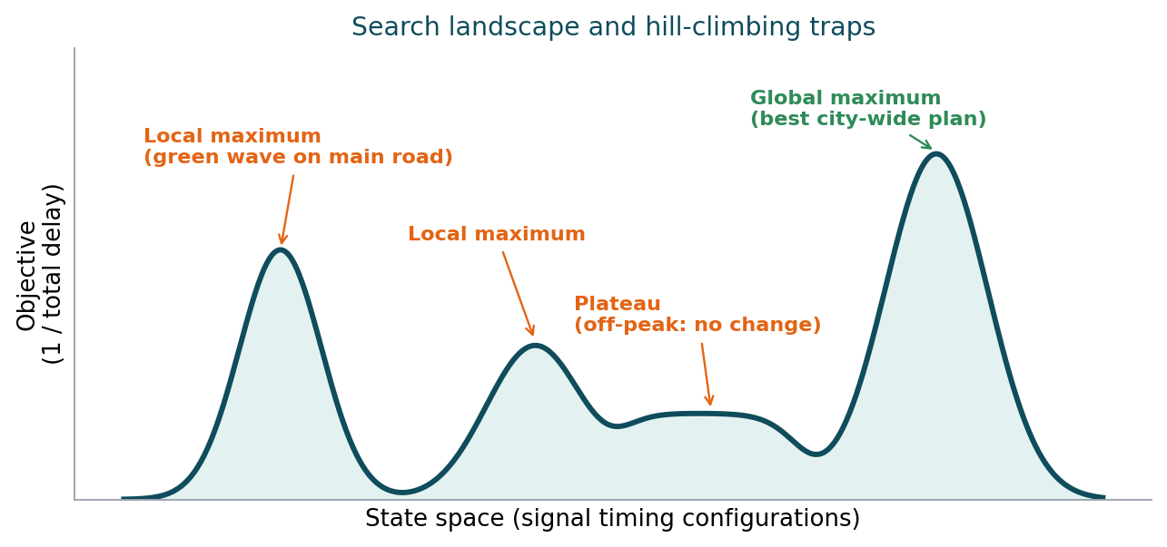
Figure 3: Local maxima and a plateau trap hill climbing; the global maximum is the best city-wide plan

(d) Simulated Annealing and Genetic Algorithms
Simulated Annealing (SA). It picks a random neighbour and always accepts an improvement. A worse move (ΔE > 0) is accepted with probability P = e^(−ΔE/T). The temperature T starts high, so the system explores widely, and is lowered gradually (cooling schedule), so the search settles into a good solution.
- Escapes local optima because uphill (worse) moves are sometimes accepted.
- Handles plateaus because random moves keep it exploring.
- Traffic example: at peak hour the system can temporarily accept a slightly worse timing at one junction to unlock a far better coordinated corridor.
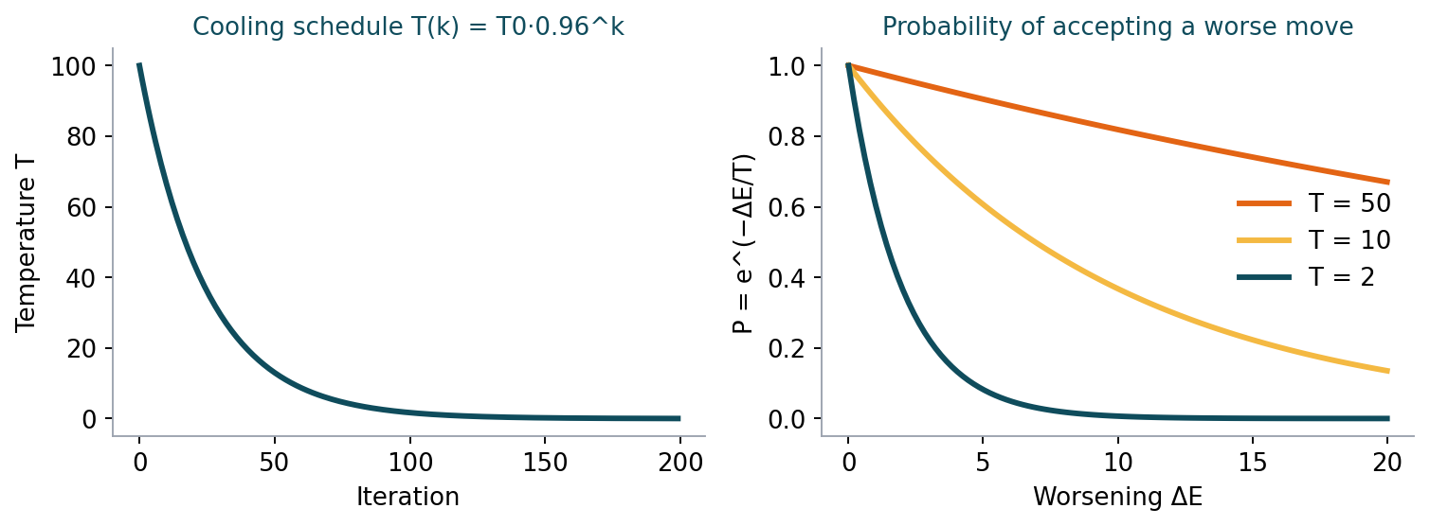
Figure 4: Simulated Annealing: cooling schedule and chance of accepting a worse move
Genetic Algorithm (GA). A population of complete signal plans evolves over generations.
- Chromosome: a vector of all timing parameters of all intersections.
- Fitness: 1 / f(x), so lower waiting time and fuel use give higher fitness.
- Selection: the best plans are chosen as parents (tournament or roulette).
- Crossover: combine the timings of two good plans, for example take the north zone from parent 1 and the south zone from parent 2, which solves the ridge problem by changing many junctions together.
- Mutation: random small changes keep diversity and avoid premature convergence.
- Elitism: keep the best plan from each generation so quality never regresses.
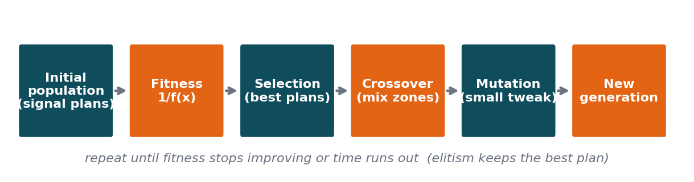
Figure 5: Genetic Algorithm cycle for evolving signal plans
Feature | Simulated Annealing | Genetic Algorithm
Candidates kept | One solution | A population of solutions
Escape mechanism | Probabilistic acceptance of worse moves | Crossover, mutation and diversity
Parallelism | Limited | Highly parallel (evaluate chromosomes simultaneously)
Cost per step | Low | Higher (many evaluations per generation)
Best use | Fine-tuning and quick online adjustment | Global exploration of large spaces

(e) Recommendation
Recommended: a hybrid (memetic) approach: a Genetic Algorithm for global search, combined with Simulated Annealing / local hill climbing for fast online refinement.
- Scalability: GA evaluates many candidate plans in parallel and can be partitioned by city zone, so hundreds of intersections remain tractable.
- Adaptability: traffic changes continuously, so the previous best plan is used as a warm start and re-optimised with SA/local search for the new conditions instead of restarting from scratch.
- Quality: population diversity and annealing both reduce the risk of getting stuck, and elitism guarantees that the plan never gets worse than the one currently deployed.
- Practicality: run GA offline on historical patterns (morning peak, evening peak, weekends), and use SA online for real-time tweaks, with a fallback to the last safe plan.
Conclusion: Plain hill climbing is too easily trapped, and systematic search cannot scale. A GA + SA hybrid gives global exploration, local fine-tuning, parallel scalability and quick adaptation to changing traffic.

Q3 | Autonomous Rover on Mars

Scenario: A rover explores unknown Martian terrain. It must navigate safely to collect samples, avoid craters and rocks, operate with limited sensing, and decide without a complete map while updating its knowledge as it explores.

(a) Why an online search agent is required
An offline search agent computes a complete plan before acting, and this assumes the full map and the results of every action are known. An online search agent interleaves computation and action: it takes an action, observes the percept, updates its knowledge, and then decides the next action.
- Unknown environment: the map is not known in advance, so the state space and action outcomes cannot be searched beforehand (an exploration problem).
- Limited sensing: the rover sees only nearby terrain, so planning must continue as new areas are revealed.
- Communication delay: signals between Earth and Mars take several minutes each way, so the rover cannot be remotely driven step by step and must decide on board.
- Irreversible or risky actions: falling into a crater cannot be undone, so each action must be chosen with the knowledge currently available.
- Dynamic surroundings: dust, sand slippage and rockfall change the terrain, so any pre-computed plan becomes stale.
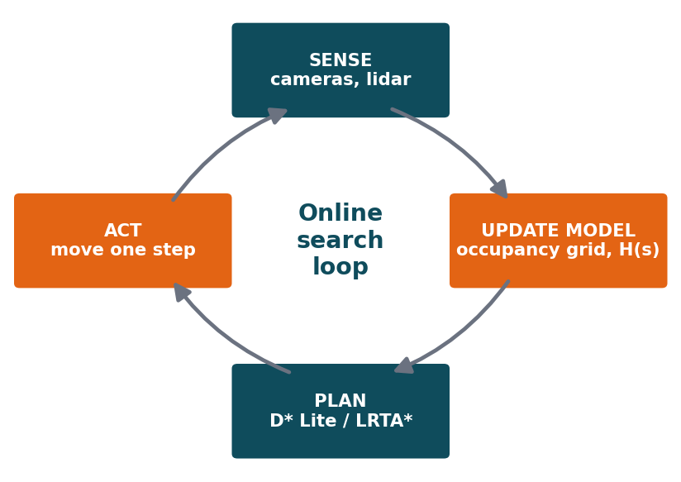
Figure 6: Online search loop used by the rover: sense, update model, plan, act

(b) Challenges of partial observability and dynamic environments
Challenge | Explanation
Incomplete percepts | Sensors (cameras, lidar) give only a limited range and can be blocked by rocks and slopes, so the rover never sees the full state.
Sensor noise and ambiguity | Dust, shadows and low-resolution data may cause a crater to be missed or a shadow to be mistaken for a hazard.
Belief state uncertainty | The rover must reason over possible states (a belief state) instead of one known state.
Dead ends and irreversibility | Exploring into a dead end wastes energy; some actions cannot be reversed, so the agent needs safe exploration.
Changing terrain | Wheel slip, soft sand and moving rocks mean the same action may have a different result later.
Resource limits | Limited battery, computing power and time force quick, low-cost decisions.
Competitive performance | Online agents are measured by how much worse they do than an agent that knew the map (competitive ratio); poor choices can make this unbounded.

(c) How the rover builds and updates its internal model
The rover maintains a map and a transition model that grow with every percept.
- Sense: read camera, lidar and wheel odometry to get the current percept.
- Localise: estimate its own position (e.g., SLAM, visual odometry, IMU).
- Update map: write the new information into an occupancy grid. Each cell is free, obstacle, hazard (crater / steep slope) or unknown. Cell confidence is updated with Bayesian (log-odds) updates, so repeated observations reduce uncertainty.
- Record outcomes: store result[s, a] = s' for every action tried, so the agent remembers what each action did.
- Maintain exploration data: keep a list of untried actions per state and a list of states to backtrack to, as in the online DFS agent.
- Update costs / heuristics: refine cost estimates H(s) with experience (as in LRTA*) and mark cells with traversal cost based on slope, roughness and risk.
- Re-plan: choose the next move using the updated model, then repeat the loop.
The LRTA* update rule shows learning from experience: H(s) = min over actions a of [ c(s, a, s') + H(s') ]. The estimated cost of a state is corrected after each visit, so the rover stops repeating mistakes and escapes local traps.
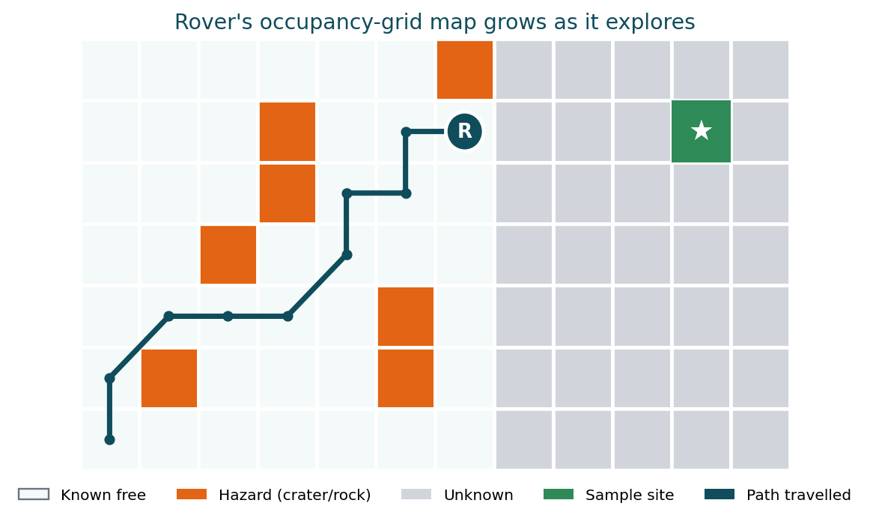
Figure 7: Occupancy-grid map: known area, hazards, unexplored cells and the path travelled

(d) Online search vs uninformed and informed search
Aspect | Uninformed (BFS / DFS / UCS) | Informed (Greedy / A*) | Online (Online-DFS, LRTA*, D* Lite)
Map requirement | Full model of states needed | Full model plus heuristic | No complete map; learns while moving
Planning style | Offline: plan, then act | Offline: plan, then act | Interleaved: plan, act, sense, replan
Use of knowledge | None about the goal | Heuristic guidance | Heuristic plus experience gathered online
Handles unknown terrain | No | No (needs known costs) | Yes
Handles changes | Must restart | Must restart | Updates incrementally
Safety / backtracking | Backtracking is free in simulation but impossible in reality | Same issue | Designed for real physical backtracking and exploration
Efficiency | Poor | Good if the map is known | Good for actual movement and real-time

(e) Most suitable approach and justification
Recommended: an online, heuristic-guided search agent, such as LRTA* / D* Lite combined with frontier-based exploration and a safety-aware cost model.
- Uncertainty: the belief map and the occupancy probabilities are updated after each percept, and D* Lite efficiently repairs the path when new obstacles are discovered.
- Adaptability: only the affected part of the plan is recomputed, so the rover reacts to new terrain in real time without restarting.
- Safety: hazard cost is added to the path cost, uncertain or unknown cells get a conservative margin, steep or ambiguous areas are avoided, and a safe mode (stop, re-sense, retreat) is triggered when confidence is low. Critical decisions may also be reviewed by ground control.
- Efficiency: heuristic guidance towards the sample site avoids aimless wandering, while exploration of frontiers expands knowledge only where useful.
Conclusion: Offline uninformed or informed search cannot work without a map. An online agent that learns the map while moving, updates its model and re-plans incrementally with a safety-weighted cost is the only approach that fits the uncertainty, adaptability and safety needs of Mars exploration.

Q4 | University Exam Timetable as a CSP

Scenario: A university wants an AI system to automatically generate exam timetables under constraints: no overlapping exams for any student, limited exam halls, some subjects must precede others, faculty availability, and special accommodations. Complexity grows with the number of courses and students.

(a) Formulation as a Constraint Satisfaction Problem
A CSP is defined by a triple (X, D, C): a set of variables X, a domain D of allowed values for each variable, and a set of constraints C that restrict combinations of values. A solution is a complete and consistent assignment, where every variable has a value and no constraint is violated.

(b) Variables, domains and constraints
Variables: one for each exam (course) c_i: Slot(c_i) is the time slot of the exam, and Hall(c_i) is the hall in which it is held.
Domains:
- Slot(c_i) ∈ {all exam slots in the exam period}, e.g. Day 1 morning, Day 1 afternoon, ... Day 10 afternoon.
- Hall(c_i) ∈ {H1, H2, ..., Hk}, restricted to halls with enough capacity for the course.
Constraint | Formal idea | Explanation
No student overlap (binary) | If courses ci and cj share at least one student then Slot(ci) ≠ Slot(cj) | A student cannot write two exams at the same time. This is the core conflict graph.
Hall capacity (global) | Exams in the same slot and hall must not exceed capacity; number of parallel exams ≤ number of halls | Limited halls and seats; two exams share a hall only if the total students fit.
Precedence (binary) | Slot(ci) < Slot(cj) if ci must precede cj | Prerequisite or dependent subjects must be scheduled in the correct order.
Faculty availability (unary) | Slot(ci) ∈ AvailableSlots(faculty of ci) | Removes slots in which the examiner or invigilator is unavailable, reducing the domain directly.
Special accommodations (unary / binary) | Hall(ci) ∈ AccessibleHalls; extra duration; separate room | Students needing extra time or accessible rooms limit hall choice and may need longer slots.
Soft constraints (optional) | Minimise back-to-back exams, spread exams evenly | Not mandatory, but improve quality; treated as an optimisation objective.

The constraint graph has courses as nodes and an edge between courses that conflict. Timetabling with only the overlap constraint is equivalent to graph colouring, where colours are time slots, which shows why the problem is NP-hard and grows quickly with size.
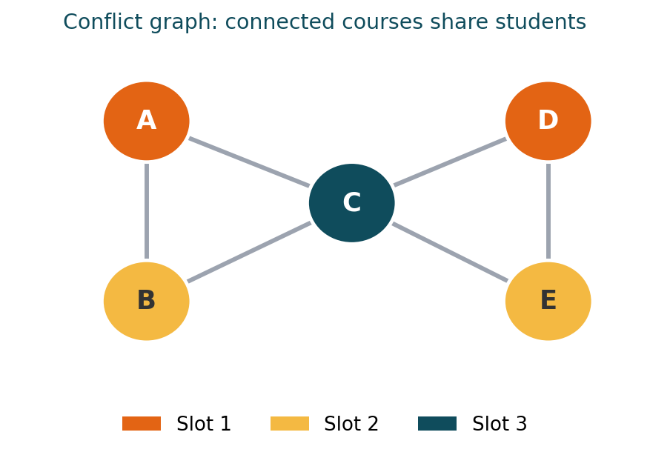
Figure 8: Conflict graph for the mini example: adjacent courses must get different slots

(c) How backtracking search works
Backtracking is depth-first search that assigns one variable at a time and checks constraints after each assignment. If a violation occurs, it undoes (backtracks) the last assignment and tries another value.
BACKTRACK(assignment):
if assignment is complete: return assignment
var = SELECT-UNASSIGNED-VARIABLE # e.g. MRV
for value in ORDER-DOMAIN-VALUES(var): # e.g. LCV
if value is consistent with assignment:
add (var = value)
result = BACKTRACK(assignment)
if result != failure: return result
remove (var = value) # backtrack
return failure

Mini example. Courses A, B, C, D; slots {1, 2, 3}. Students overlap between A-B, A-C, B-C and C-D. Assign A=1. B cannot be 1, so B=2. C conflicts with both A and B, so C=3. D conflicts only with C, so D=1 (or 2). All constraints hold and a timetable is found. If, for example, only two slots were available, C would have no value and the search would backtrack to change A or B.
Variable and value ordering heuristics make backtracking far more efficient:
- MRV (Minimum Remaining Values): choose the exam with the fewest legal slots left, so failures are found early.
- Degree heuristic: among ties, choose the exam in conflict with the most unassigned exams (e.g. a core subject taken by many students).
- LCV (Least Constraining Value): try first the slot that removes the fewest options for neighbouring exams.

(d) Constraint propagation and forward checking
Plain backtracking discovers a conflict only when it reaches the variable that has no valid value, which may be many steps later. Forward checking looks ahead: whenever a variable is assigned, it removes inconsistent values from the domains of all connected unassigned variables, and it stops immediately if any domain becomes empty.
Step | Domain situation
Initial domains | A={1,2,3}, B={1,2,3}, C={1,2,3}, D={1,2,3}
Assign A=1 | Forward checking removes 1 from neighbours B and C: B={2,3}, C={2,3}, D={1,2,3}
Assign B=2 | Remove 2 from C: C={3}. Domain still non-empty, so continue.
Assign C=3 | Remove 3 from D: D={1,2}. A valid assignment exists.
Failure case | If a domain ever becomes {}, the algorithm backtracks immediately without exploring a doomed branch.

- Benefit: it prunes large parts of the search tree early, reduces backtracking, and works well with MRV (MRV picks the variable with the smallest domain, which forward checking keeps up to date).
- Stronger propagation: Arc Consistency (AC-3) and Maintaining Arc Consistency (MAC) detect inconsistencies that forward checking misses, at a higher per-step cost.

(e) Real-world challenges and best strategy for scalability
Challenge | Impact / handling
Problem size | Thousands of courses and students create a huge search space; the problem is NP-hard.
Over-constrained problems | Sometimes no perfect timetable exists. Some constraints must become soft with penalties (partial CSP / constraint relaxation).
Hard vs soft constraints | Hard constraints (no clash, capacity) must hold; soft ones (student fatigue, fairness) are optimised.
Late changes | A student, faculty or hall change late in the process should trigger repair, not a full re-solve.
Fairness and quality | Even spreading of exams, gaps between exams, and hall utilisation affect satisfaction.
Data quality | Accurate enrolment data is essential; errors silently create hidden clashes.

Recommended strategy (hybrid):
- Reduce domains first using unary constraints (faculty availability, accommodation halls) and preprocessing with arc consistency.
- Solve with backtracking search + MRV + degree + LCV + forward checking / MAC to quickly find a feasible timetable.
- Decompose the problem (by faculty, department or week) where constraints are loosely coupled, and solve the parts independently.
- Improve and repair with local search (Min-Conflicts) or simulated annealing, which also handles soft constraints and late changes efficiently.
Conclusion: Pure backtracking does not scale and pure local search can miss feasibility. Combining constraint propagation and heuristic-guided backtracking with min-conflicts repair gives a scalable, flexible timetable generator that satisfies all hard constraints and improves soft-constraint quality.

Q5 | Strategic Game AI (Minimax and Alpha-Beta)

Scenario: A gaming company is building an AI opponent for a real-time strategy game. The AI competes against humans, must decide within strict time limits, evaluates complex states with many possible moves, and faces an extremely large decision tree.

(a) How Minimax models the problem
Minimax models a two-player, zero-sum, turn-taking game, where one player's gain is exactly the other's loss. The game is represented as a tree.
- MAX = the AI, which tries to maximise the evaluation score.
- MIN = the human opponent, assumed to play optimally to minimise the AI's score.
- State: current game situation. Actions: legal moves (build, attack, move units). Result: the new state after a move. Terminal test: win, loss or draw. Utility: +1 win, 0 draw, -1 loss (or a numeric score).
Minimax value: MINIMAX(s) = Utility(s) if s is terminal; max over actions of MINIMAX(Result(s,a)) if MAX is to move; min over actions of MINIMAX(Result(s,a)) if MIN is to move. The AI picks the move leading to the child with the highest minimax value, assuming the best counter-play by the human.

(b) Computational challenges of large game trees
- Time complexity O(b^m) where b is the branching factor and m is the maximum depth. Space is O(b·m) with depth-first implementation.
- Chess has b ≈ 35 and about 100 plies, giving roughly 35^100 nodes, which is impossible to search fully. An RTS game is worse, because many units can act each turn, so b can be in the hundreds or thousands.
- Real-time limit: the move must be returned within milliseconds, so complete search to terminal states is impossible.
- Complex state evaluation: each node needs a costly evaluation of units, resources and positions.
- Repeated states and horizon effect: the same positions occur via different move orders, and a fixed depth cutoff may miss a disaster just beyond the horizon.
Therefore the search must be depth-limited, pruned and heuristically evaluated.
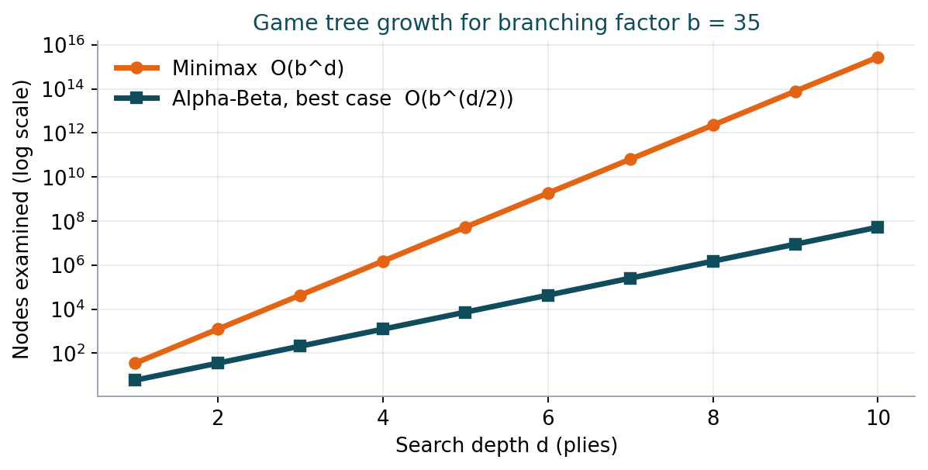
Figure 9: Alpha-Beta in the best case searches about twice as deep for the same effort

(c) How Alpha-Beta pruning improves efficiency
Alpha-Beta computes the same result as Minimax but skips branches that cannot affect the final decision. It carries two bounds:
- α (alpha): the best (highest) value MAX can already guarantee on the current path.
- β (beta): the best (lowest) value MIN can already guarantee on the current path.
Pruning rule: stop exploring a node as soon as α ≥ β, because the opponent would never allow the game to reach it.
Worked example. MAX root with three MIN children. Leaves: Child 1 = [3, 12, 8], Child 2 = [2, 4, 6], Child 3 = [14, 5, 2].
Step | What happens
Child 1 | MIN sees 3, 12, 8 and returns min = 3. Root: α = 3.
Child 2 | First leaf is 2, so MIN's value is at most 2, i.e. β = 2 ≤ α = 3. Leaves 4 and 6 are pruned; MAX will never choose this branch.
Child 3 | Leaves 14, 5, 2 give min = 2, so Child 3 = 2.
Root value | max(3, 2, 2) = 3, identical to full Minimax, but with fewer evaluations.

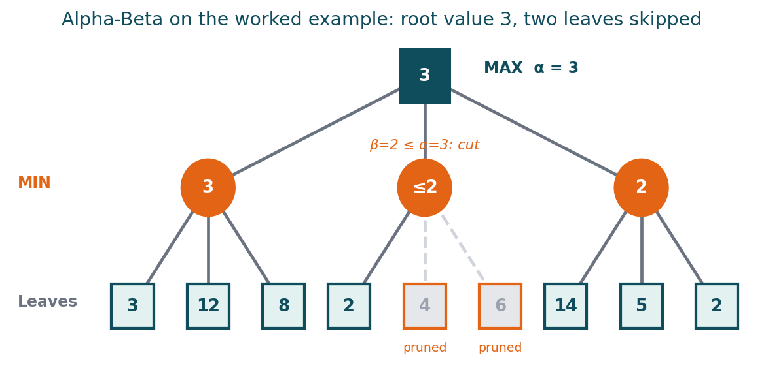
Figure 10: Alpha-Beta trace: the second MIN node is cut after its first leaf
- Best case (perfect move ordering): O(b^(m/2)), which roughly doubles the search depth in the same time. Average case with good ordering is close to this; the worst case is O(b^m), the same as Minimax.
- Move ordering matters: examine the most promising moves first (captures, high-value attacks, killer moves, previous best move) so pruning happens early.
- Correctness: pruning never changes the optimal move, it only removes work.

(d) Designing an evaluation function
When the search is cut off at a depth limit, a heuristic evaluation function estimates how good the position is for the AI. A common form is a weighted linear combination:
Eval(s) = w1·Resources + w2·Army + w3·Economy + w4·Position + w5·Tech + w6·Safety
Factor | How it is measured | Why it is included
Army strength (w1) | Number, health and attack power of own units minus enemy units | Military superiority decides fights and map control
Economy / resources (w2) | Resource stock, number of workers, income rate | Resources convert into future units and buildings
Map and position control (w3) | Territory held, chokepoints, high ground, expansion bases | Position gives vision and tactical advantage
Technology / upgrades (w4) | Tech level, unlocked units and upgrades | Shows long-term power and strategic options
Base safety (w5) | Health of key buildings, distance of enemy forces from the base | Losing the base means losing the game
Production capacity (w6) | Number of production buildings and idle time | Ability to quickly reinforce

- Terminal states: return a very large positive value for a win and a very large negative value for a loss.
- Design rules: the function must be fast to compute, consistent with true winning chances, normalised so factors are comparable, and symmetric (a good position for the AI equals a bad position for the human).
- Tuning weights: use expert knowledge first, then refine by self-play, simulation and machine learning from game records.

(e) Balancing optimality and real-time performance
Perfect play is impossible in the time available, so the aim is the best move achievable within the time budget:
- Depth-limited Alpha-Beta search with the evaluation function at the cutoff.
- Iterative deepening: search depth 1, then 2, 3, ... and keep the best move from the last completed depth, so a valid answer always exists when the clock runs out (an anytime algorithm).
- Move ordering: transposition table (cache of repeated states), killer-move and history heuristics, and previous-iteration best move first.
- Quiescence search: extend search in unstable positions (ongoing battles) to reduce the horizon effect.
- Abstraction and selective search: group units into squads and use macro-actions (attack, expand, defend) to cut the branching factor; use beam search or forward pruning for unlikely moves.
- Difficulty control: adjust depth limit or time budget to create easy, medium and hard opponents.
Conclusion: Use Alpha-Beta search with iterative deepening, strong move ordering, a transposition table and a well-tuned evaluation function, operating under a strict time budget with abstraction of actions. This gives near-optimal decisions without breaking real-time limits. For very large branching factors, Monte Carlo Tree Search (MCTS) is a strong alternative or complement.

